**Report Purpose**: When lending money to prospective clients it is important to examine any potential risks. This report identifies different **key indicators for credit risk** that could have influence on whether a client is **approved** or **declined** on a loan. Our data shows in the last 7 years a steady rate of application approvals and denials. Some **key indicators** analyzed were **debt to income**, **average income**, **age,** and **credit score.**

**Debt to income**: Analysis shows that *debt to income (DTI)* is one key indicator for credit risk. DTI is calculated by taking an individual’s financial liabilities over their assets, or a client’s total monthly debt payments divided by their monthly income. DTI was examined over the last 7 years and it is clear that those with higher debt to income have their loans approved far less than those with lower debt to income. In 2024 alone Cedar Crest Financial had 366 total applicants with only 77 of them being approved, or 21%. Those who were declined (289 applicants) had an average DTI of .51. This mean that 51% of their income was tied into debt and adding more debt would provide further hardship. Contrast to those declined, those who were approved in 2024 had a DTI of only .16, or 16% of their income was tied up with debts. DTI is an important risk indicator because applicants with higher DTI would potentially have a harder time paying back loans if more debt is added in.

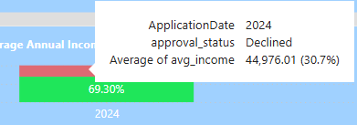**Income:** Like with DTI, *income* would play a significant role in risk analysis. Our data shows that individuals who earn more annually were more likely to be approved for their loan. In 2024, the average income for our clients who were approved was $101,505.68 while the average income for those where declined was $44,976.01 Like DTI, income plays a significant role when calculating risk due to being part of the equation used to calculate DTI. Those with larger annual income would be able to take on more debt and it would take much more for their DTI to be over underwriting’s .46 (46%) DTI threshold for application approval.

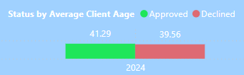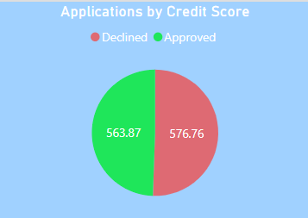**Age and Credit Score:** The last two indicators of risk examined were the *average age* and the *average credit score* of our applicants. While they did play a role in underwriting decision making, our data shows that average age and credit scores were not as significant of roles in determining risk as DTI and income. In 2024, the average age of applicants who were declined was 39 years old. The average age of those approved was 42 years of age. The average credit score in our data gave interesting insights. The average credit score of those approved was actually lower than those declined. The average credit score of those approved was 564 while those declined had an average score of 577.